LIFE CYCLE OF AN ACTIVITY

The Lifecycle of an Activity comprises a collection of methods.

These methods are: OnCreate(), OnStart(), OnResume(), OnPause(), OnStop(), OnDestroy(), OnRestart().

>> OnCreate() : OnCreate() method is used for initializing the class as well as providing the view.

>> OnStart() : OnStart() method will start the application.

>> OnResume() : OnResume() method will create interaction with activity.

>> OnPause() : OnPause() method will partially hide the activity.

>> OnStop() : OnStop() method will completely hide the activity.

>> OnDestroy() : OnDestroy() method will destroy the application.

>> OnRestart() : OnRestart() method will called after your activity has been stopped, prior to it being started again.

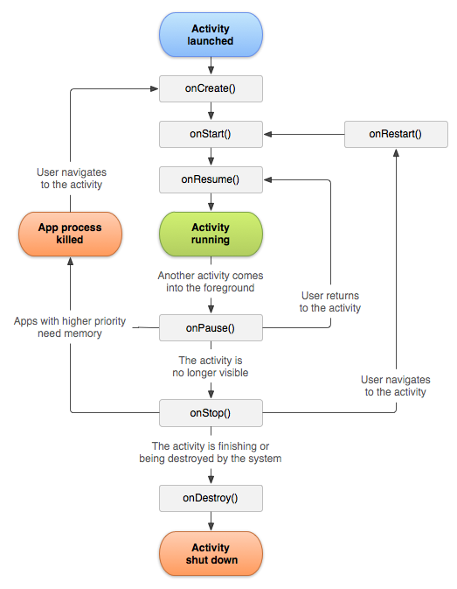

****************PROGRAM***********************

package com.example.lenovo.shubham;

import android.support.v7.app.AppCompatActivity;

import android.os.Bundle;

import android.util.Log;

public class First extends AppCompatActivity {

@Override

protected void onCreate(Bundle savedInstanceState) {

super.onCreate(savedInstanceState);

setContentView(R.layout.activity_first);

}

@Override

protected void onStart() {

super.onStart();

Log.e("App","onStart is running!!");

}

@Override

protected void onResume() {

super.onResume();

Log.e("App","onResume is running!!");

}

@Override

protected void onPause() {

super.onPause();

Log.e("App","onPause is running!!");

}

@Override

protected void onStop() {

super.onStop();

Log.e("App","onStop is running!!");

}

@Override

protected void onDestroy() {

super.onDestroy();

Log.e("App","onDestroy is running!!");

}

}